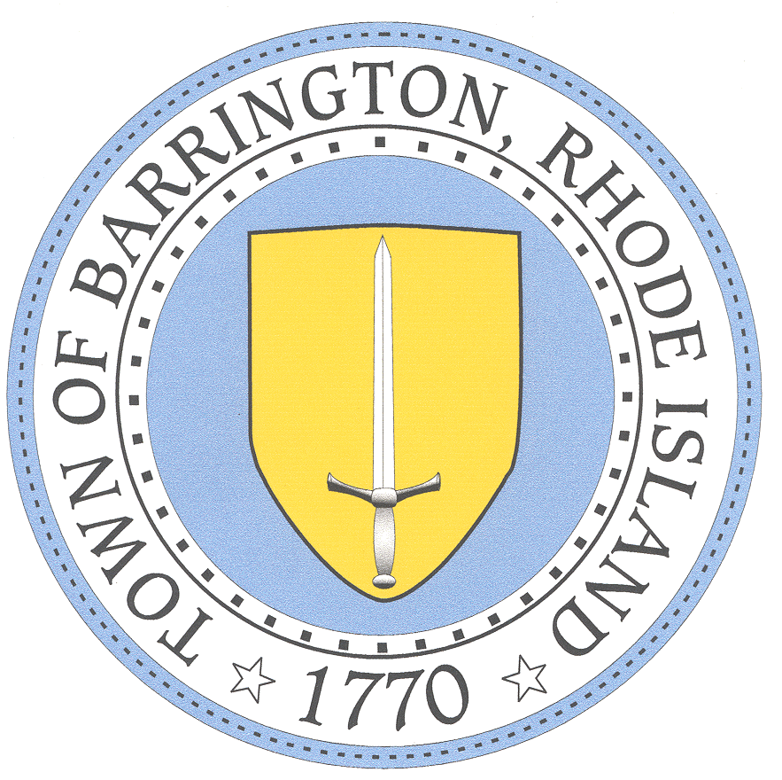

BARRINGTON PUBLIC SCHOOLS www.barringtonschools.org

283 County Road, P.O. Box 95 Barrington, Rhode Island 02806 Tel: 401-245-5000 Fax: 401-245-5003

Michael B. Messore, III
Superintendent

Paula A. Dillon, Ed.D. Douglas E. Fiore
Assistant Superintendent Director of Administration & Finance
Kristen C. Matthes David J. Burrows Director of Pupil Personnel Services Director of Technology

Date: _____________

Parent/Guardian/Student: ______________________

Address:

RE: Student Name: ___________________________
DOB:

Dear _______________________

Your student has been identified as an eligible student under Section 504 of the Rehabilitation Act of 1973. Enclosed please find the Annual Notice to Parent and Students Rights under Section 504. Barrington Public Schools is required to send this notice to you. Should you have any questions, please feel free to contact me.

Sincerely,

The Barrington Public Schools does not discriminate on the basis of race, color, national or ethnic origin,
gender, religion, disability, age, sexual orientation, gender identity or expression, citizenship, or status as a disabled veteran, or past or present honorable military service with respect to access to, the provision of, or employment in its educational services, programs and activities, including admissions, athletics and other district programs.

